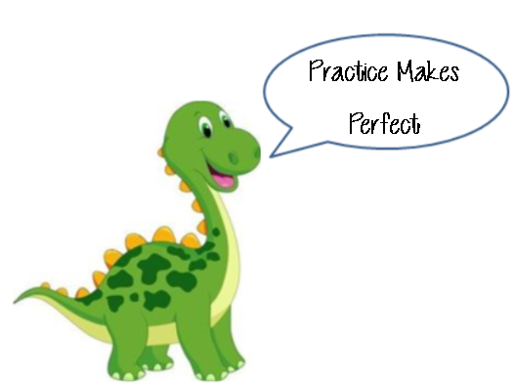**Name: __________________________  
Date: ___________________________**

**Lesson 2-4: Surface Area Mixed Practice**

**Learning Goals: #1: How do I determine the net of a 3D figure? #2, #3: How do I find the surface area of prisms?  
#4: How do I find the surface area of cylinders? #6: How do I find the surface area of a sphere?  
#7: How do I find the surface area of a cone?**

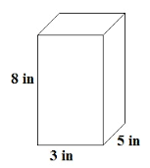**Learning Goal #1: Determining the Net of a 3D Figure**

1. Draw the net of the following rectangular prism:
2. Draw the net of a rectangular prism that has a length of 12ft., a width of 15ft., and a height of 24ft.
3. Mr. Mastrota is having a new roof made for the top of his house. It is being made at the factory and then is being shipped to be placed on top of his house. The top of his house is shown in the below diagram. The factory workers need to figure out the dimensions of each piece of the roof in order to make it. *Help them draw the blueprints (net) of the roof.*

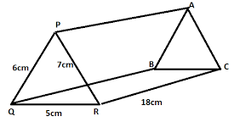

**Learning Goals #2, #3: How do I find the Surface Area of Prisms?**

1. 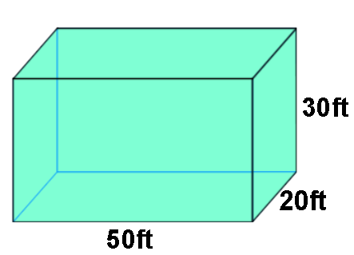Mrs. Layton is an aspiring magician and she needs our help constructing one of the props for her new trick. She is looking to make herself disappear in a box that is in the shape of a rectangular prism. She needs our help *calculating the total surface area* of the box below so that she can construct the box.
2. **a.** Find the surface area of Mr. Mastrota’s roof shown in the diagram below:

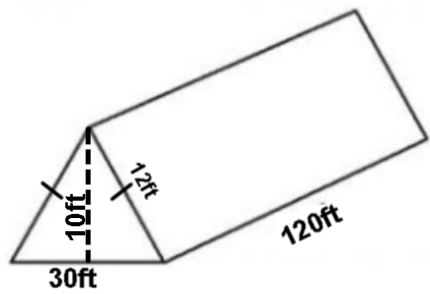

**b.** If the roofing of Mr. Mastrota’s roof cost $5.95 per square foot, how much would his entire roof cost to make?

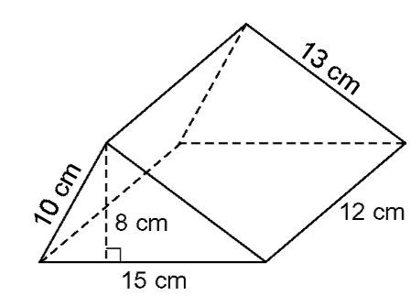

1. Calculate the total surface area of the following triangular prism.

**Learning Goal #4: How do I find the Surface Area of Cylinders?**

1. 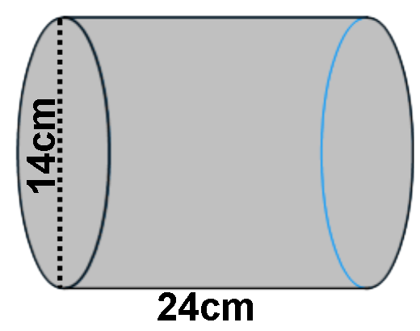Find the total surface area of the following cylinder to the nearest tenth of a square centimeter.
2. Johnny was playing around with an empty paper towel roll and was using it as a telescope. Johnny wants to know, how much cardboard was used to make the roll, which has a diameter of 12cm and a length of 30cm. Round your answer to the nearest square centimeter (make sure to identify what surface area you will be finding).

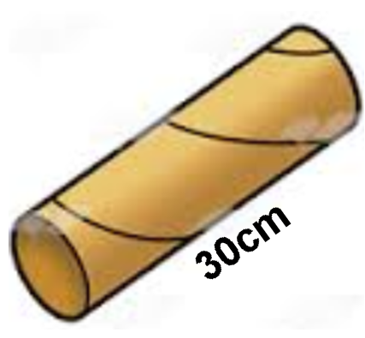

1. The total surface area of a cylinder is 108 in2. The radius of the cylinder is 6in. What is the height of the cylinder?

**Learning Goal #6: How do I find the Surface Area of Spheres?**

1. Calculate the total surface area of the following sphere. Leave your answer in terms of pi.

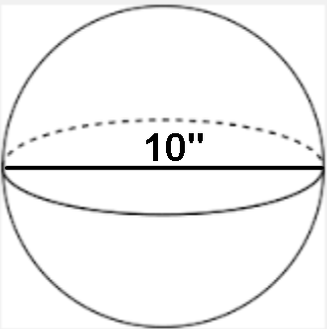

1. The total surface area of a sphere 144 cm2. What is the diameter of the sphere?
2. Bob was given the fact that the total surface area of the following figure was cm2. He was then asked to find the radius of the sphere. His work is shown below. **Explain** and **correct** his errors.

**Hint!** Try answering the question first how you normally would, and then look to see if you spot any differences!

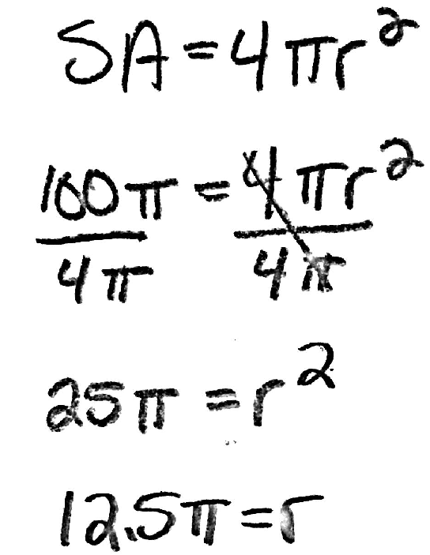

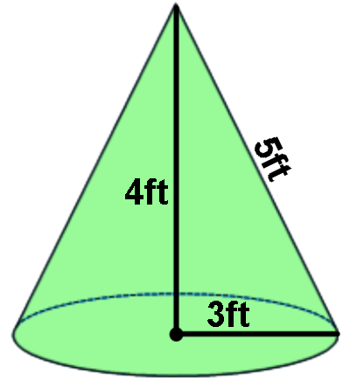**Learning Goal #7: How do I find the Surface Area of Cones?**

1. Find the total surface area of the following cone in terms of Pi:
2. Sarah buys a box of ice cream cones and wants to determine how much dough she needs to make the cone.   
   **a.** Determine how much surface area Sarah needs to make the cone shown to the right to the nearest tenth.

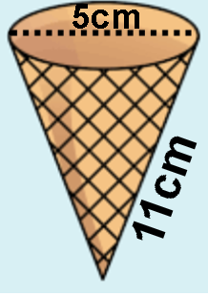

**b.** If it costs 3 cents per square centimeter of dough, how much would Sarah need to spend to buy enough dough to make one cone.   
  
  
  
  
  
  
  
  
**c.** If Sarah wanted to make a batch of 20 ice cream cones, how much dough would she need to buy?

1. How much would it be to purchase this amount of dough?

**Step It Up!**

1. The total surface area of a rectangular Prism is 94 square feet. If the length is 4feet, the width is 3 feet then what is the height?
2. The following diagram shows a cone, with a hemi-sphere attached at the base of the cone. What is the total surface are of the object in terms of Pi.

